**Rock Cycle Activity**

Imagine you are a piece of rock and are moving through the rock cycle. For each move you take, you will roll a dice to determine where you will go.

Use the table below to record your movements. You should say where you started, where you have ended up, and how you got there. In the **How I got there** column you should name of the process that moved or changed the rock (e.g. weathering, melting, heat, pressure).

|  |  |  |
| --- | --- | --- |
| **Where I started** | **Where I moved to** | **How I got there** |
|  |  |  |
|  |  |  |
|  |  |  |
|  |  |  |
|  |  |  |
|  |  |  |
|  |  |  |
|  |  |  |
|  |  |  |
|  |  |  |
|  |  |  |
|  |  |  |
|  |  |  |
|  |  |  |
|  |  |  |
|  |  |  |
|  |  |  |
|  |  |  |
|  |  |  |
|  |  |  |

**Questions**

1. Why did you use a dice to determine how you moved through the rock cycle?
2. How many times did you visit the mantle? Describe the different routes you took to get there.
3. How many times were you weathered into sediments? Describe the different routes you took to get there.
4. Trace your path through the rock cycle by adding numbered arrows between the components of the cycle. If you stay in the same place, show that with a dot.

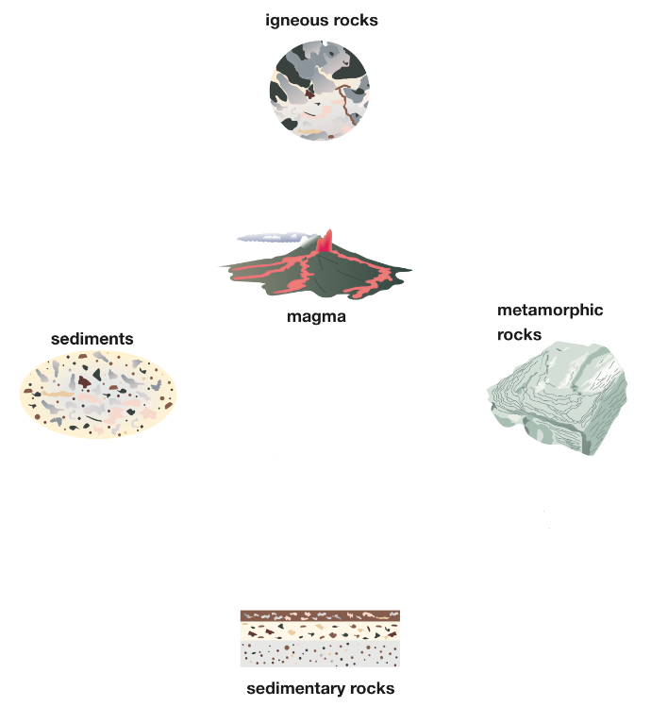

1. A cycle usually refers to events that move in a circular pattern. From this activity, do you think it should be called a cycle? Why or why not?